Fault | Possible Causes
No Sound | A flat battery or battery inserted incorrectly  Check/Change battery | Aid on the wrong programme  Turn aid on and off again | Wax in the ear mould  Wash the mould or use the tube cleaner | Condensation in the tubing  Use the air puffer
Reduced Power | Condensation in the tubing  Use the air puffer | Aid on the wrong programme  Turn aid on and off again | Wax in the ear mould  Wash the mould or use the tube cleaner
Feedback/Whistling | Ear mould incorrectly fitted  Check the fitting | Wax in the ear mould  Wash the mould or use the tube cleaner | Condensation in the tubing  Use the air puffer | Wax in the ear  Discuss with the GP regarding wax removal
Intermittent sound/crackling | Condensation in the tubing  Use the air puffer | Wax in the ear mould  Wash the mould or use the tube cleaner
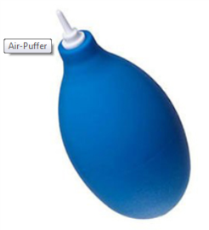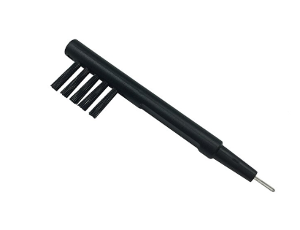
Air Puffer is available to purchase online at own cost.
www.actiononhearingloss.org.uk / Tel: 03330 144525
Tube cleaners and brushes are supplied by the department when requested.
The instructions below are to help resolve possible causes of faults but if you are unsure then please contact the department.
www.C2HearOnline.com

